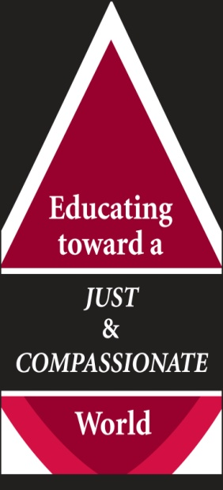
Dominican Colleges Colloquium
Edgewood College
June 19-22, 2008

CALL FOR PAPERS /PRESENTATIONS

The Spirit of the Lord is upon me and has anointed me to bring
glad tidings to the poor. God has sent me to proclaim liberty to captives, recovery of sight to the blind, to let the oppressed go free, and to proclaim a year acceptable to the Lord. (Lk 4:16-18/Is 61:1-2)

November 7, 2007
Feast of All Dominican Saints

With great joy and anticipation we announce the
Tenth Dominican Colleges Colloquium.
We look forward to gathering in beautiful Madison, Wisconsin for study and reflection about the multiple ways that our Dominican Colleges and Universities are
Educating toward a JUST and COMPASSIONATE World.

As we consider our various roles in Dominican higher education we can ask ourselves:
- How does what we are doing contribute to building a more just and compassionate world?

- In what ways does my discipline, department or office awaken in students an awareness of the gifts they have to contribute to make the world a better place?

- Are there assumptions, attitudes, behaviors or worldviews within our various programs or disciplines which reinforce systems of injustice or attitudes of self-centeredness and need to be challenged or changed?

- How do you teach toward creating a just and compassionate world?

We welcome proposals for presentations/papers that share your insights and experience in the Humanities, Fine Arts, Natural Science, Social Sciences, Professional Programs, Service Learning, Student Services, University/College Ministries, Athletics, Environmental Programs or other efforts on your campus.

Please forward your proposals electronically by December 15, 2007 to:
Hopkins@edgewood.edu and/or by hard copy to:

Maggie Hopkins, OP
Edgewood College
1000 Edgewood College Drive
Madison, WI. 53711

